Lawyer Referral Service
Connect. Serve. Grow.
Dear Attorney:
Here at the Harford County Bar Foundation, we strive to connect residents of Harford and Cecil Counties with the legal support they need. As the primary referral service in both counties, we carefully screen requests and match individuals with attorneys in our trusted network. Join the Lawyer Referral Service and help us expand access to quality legal representation throughout our community.
What is the Lawyer Referral Service?
The Lawyer Referral Service connects individuals in need of legal assistance with qualified lawyers offering paid representation in specific areas of law. HCBF actively promotes the service through our website, outreach, and community partnerships, helping generate high-quality referrals.
Why join:
Connect - Gain new clients and build your professional network
Serve - Help individuals in our community access legal support Grow - Expand your practice through high-quality referrals
Through the Lawyer Referral Service, you are able to assist clients in your area who are seeking legal services.
Together, we can offer top-tier legal help, ensuring community members get the representation they need.
To become a member please submit the following:
Completed registration forms
Malpractice Insurance Certification and Indemnification
A copy of your legal malpractice carrier’s Declaration Sheet
$135 annual fee – Payable by check to Harford County Bar Foundation or online via the contact page at www.harfordcountybarfoundation.org
If you are a current member with no changes to your practice areas or malpractice insurance, renewing your membership is simple. Just submit the $135 renewal fee.
We look forward to partnering with you.


Best regards,
Jennifer Vido, Executive Director
Harford County Bar Foundation
18 S. Main Street, Suite 201, Bel Air, MD 21014
T: 410.836.0123
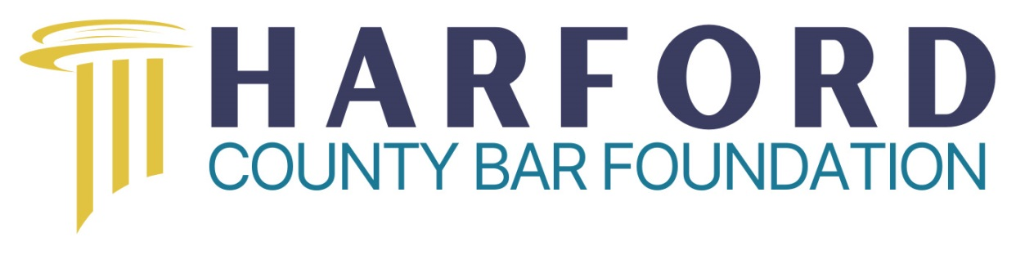
Promoting Equal Access to Justice
18 South Main St., Suite 201, Bel Air, Maryland 21014
(410) 836-0123

Date: _____________________________ Years Practicing Law in MD_______
Years Practicing Law in another State______

Attorney Name: ____________________________________________________

Firm: _____________________________________________________________

Address: __________________________________________________________

Telephone Number: _________________________________________________

Email address: ______________________________________________________

Firm’s website: _____________________________________________________

Please circle the program or programs in which you would like to participate:

Judicare Pro Bono Reduced Fee Criminal Reduced Fee

Please circle the location in which you will assist clients:

Harford County Cecil County

Has the Attorney Grievance Commission or similar agency in another state ever taken disciplinary action against you? _____

If so, which agency? ______________________________

Please check off the areas of law in which you practice. Feel free to circle, cross out, or add specific information next to each area of law.

_____Administrative Law Hearings
(County, State, Federal)
Specify: ________________________________

_____Agriculture

_____Automobile Accidents (Personal injury, Property damage, Insurance)

_____Banking (Financial Institution/Consumer)

_____Bankruptcy/Collections

_____Business

_____Consumer Protection
(Product liability, Misrepresentation)

_____Construction
Specify: ________________________________

_____Contracts
Specify: ________________________________

_____Criminal (Adult/Juvenile)

_____Education
_____Elder (Medicare, Protection of Assets, Nursing Home)
Specify: ________________________________

_____Employment (Employer/Employee)
_____Unemployment claims
_____Wrongful Termination
_____Employment Contracts
_____Worker’s Comp

_____Environmental

_____Estate and Trusts (Planning, Probate, Wills, Power of Attorney)

_____Family (Divorce, Custody, Child support, Adoption, Guardianship, Name Change)

_____Federal Gov. Act Compliance
(ADA, EEO, Fair Housing, FLSA,OSHA)

_____Foreclosure

_____Housing
_____Landlord/Tenant
_____Subsidized/Section 8
_____Homeowner’s Associations
_____Construction

_____Identity Theft

_____Insurance Coverage/Regulation (Insurer, The Insured)
Specify: ________________________________

_____Intellectual Property (patents, copyrights, trademarks)

_____International

_____Litigation/Appellate
_____State
_____Federal

_____Malpractice
Specify: ________________________________

_____Mediation

_____Military/Veterans Benefits

_____Municipal Laws, Regs., Ordinances

_____Personal Injury/Torts
Specify: _______________________________________

_____Property
_____Real(Residential/Commercial)
(deeds, zoning, closing)
_____Personal

_____Social Security (SSI, SSDI)

_____Taxation (Individual/Business)

_____Other_____________________________

Promoting Equal Access to Justice
18 South Main St., Suite 201, Bel Air, Maryland 21014
(410) 836-0123

MALPRACTICE INSURANCE CERTIFICATION AND
INDEMNIFICATION AGREEMENT

I HEREBY CERTIFY that I maintain professional liability insurance in the minimum amount of $100,000/$300,000 and agree to keep a policy in force during the entire time I am a member of the Harford County Bar Foundation’s Lawyer Referral Service and will notify Harford County Bar Foundation of any changes in policy number, date of expiration, or coverage.

I HEREBY AGREE to indemnify and save harmless the Harford County Bar Foundation for and against any and all liability arising from my serving as a member of the Lawyer Referral Service and/or my representation of any lawyer referral clients.

Name of Carrier_______________________________ Policy Effective Date______________

Policy Number_________________________ Coverage Amount________________________

Attorney Signature________________________________ Date Signed _________________

NOTE: YOU MUST ATTACH A COPY OF THE COVER PAGE(S) OF YOUR POLICY INDICATING AMOUNT OF COVERAGE AND TERMINATION DATE OF POLICY

